It’s great to read in bed because:

- I get peace when I’m in bed. (Kelsey)
- It’s really comfy, warm and quiet so I can just relax and concentrate on my book. (Isla)
- I like to just get comfy and I could just sit and read the whole book because I enjoy it more while sitting there and all that draws your attention is the book. (Kady)
- If you go to sleep whilst reading you’re comfy and you tend to dream about what your mind thinks is coming next in the book. (Bethany)
- If you read a good story before you go to sleep you might have better dreams. I also like to sit on my windowsill to read because it is fun. (Leah)
- It helps me feel more tired and because it relaxes you. (Alice)
- It is quiet and peaceful. (Rachel)
- You can relax and read for as long as you want. (Katlyn)
- It is comfy and warm. (Euan)
- It’s really comfy and when my bedroom door is closed my dad knows NOT to disturb me! (Erin)
- There are no disruptions and it’s nice and quiet. (Megan)
- It is relaxing. (Cameron)
- It is comfy and you can always concentrate more if you are on your own and if it is quiet. (Alyx)
- In bed you can relax while reading. (Zachary)
- It’s quiet. (Duncan)
- You are all alone and you can imagine what is going to happen next. (Navdip)

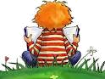


A selection of books read as part of
Annan Academy’s READ SIX BOOKS IN SIX WEEKS Summer Challenge.

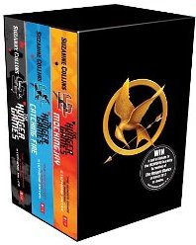
The Hunger Games

The Hunger Games has to be one of the best books that I have ever read. I recommend this book to readers who enjoy action-packed adventures.
Zachary Hannay

I love the style this author writes in. With all the detail throughout the book, it’s clear why this book is many people’s favourite book. I would love to go into more detail but I do not want to give anything away in case you have not read it.
Bethany Dunion

It’s not a book for everyone. It’s about trying to stay alive on a TV show. That’s not a joke (although it may sound like one) so you will have to read it yourself.
It is exciting and has got a bit of a scary sort of theme. It’s a great book and that’s why I liked it. I would recommend it to people who are quite adventurous and like serious things.
Leah Ophir

I liked The Hunger Games: Catching Fire because it’s got lots of action in it. Also it is futuristic and modern. My favourite part of the book is when there is a massive battle at the end of the Quarter Quell and Katniss shoots an arrow into the force field causing it to explode.
Duncan Walker
1
10

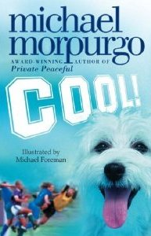
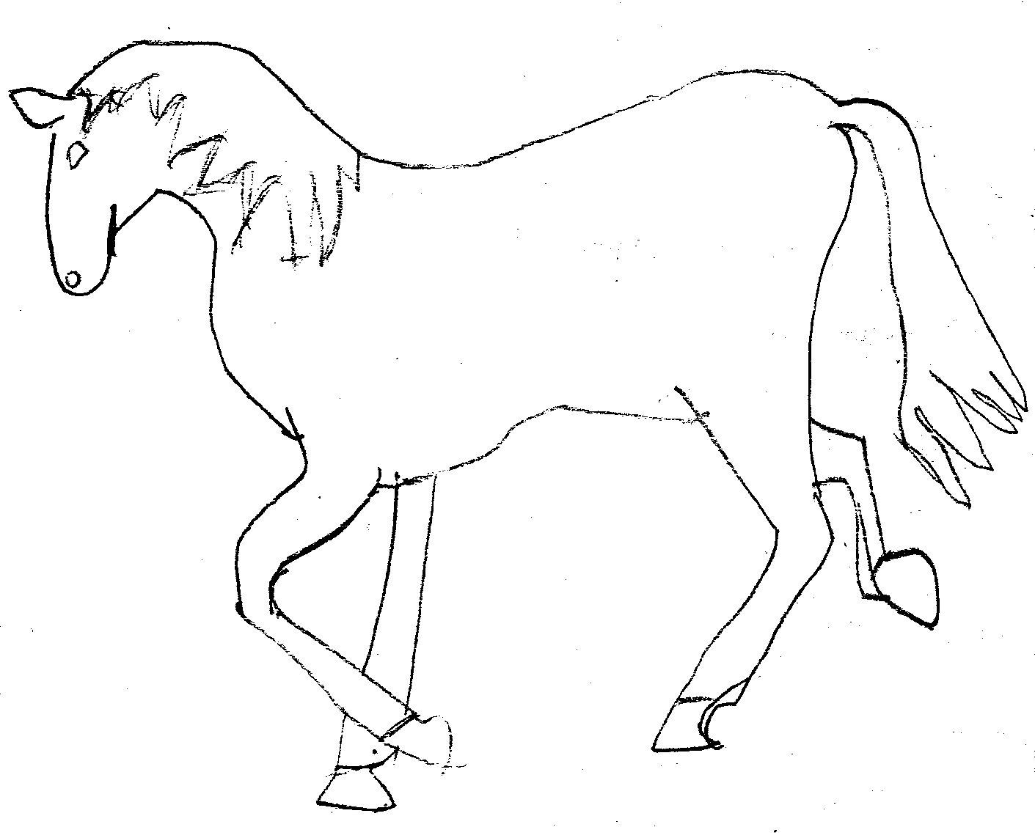
One of my favourite books of the six was War Horse by Michael Morpurgo because it was interesting to see what life was like in the war.
Rachel Jackson

War Horse was really good but sad especially for me with horses of my own.
Isla Clark

Cool! by Michael Morpurgo is about a boy called Robbie who gets knocked unconscious by a car when he runs after his dog, Lucky. Unfortunately he is in a coma after the accident. In the coma he can hear but not do anything else.
People come and visit him and tell him to wake up and he tries and tries but he just can’t. Even his favourite football player, Zola, can’t wake him up. You have to keep on reading to the end to find out if he will ever come out of his coma.
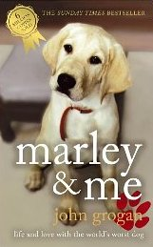
This is a very descriptive and moving book. I would thoroughly recommend Cool! to anyone.
Kayleigh Proudfoot

I liked how Marley and Me by John Grogan was a real story.
Rachel Jackson

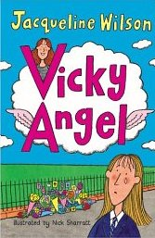
Once again Jacqueline Wilson was one of the favourite authors of the summer.

Clean Break was really good and sometimes I couldn’t put the book down although I didn’t think it was fair when her granny kept calling her fat.
Isla Clark

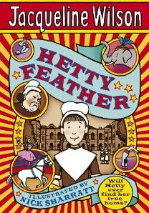
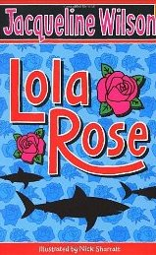
Other books by Jacqueline Wilson recommended by S1 include:

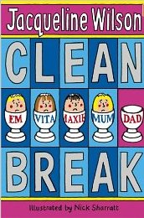

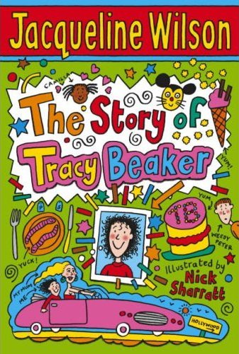
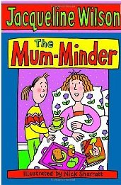

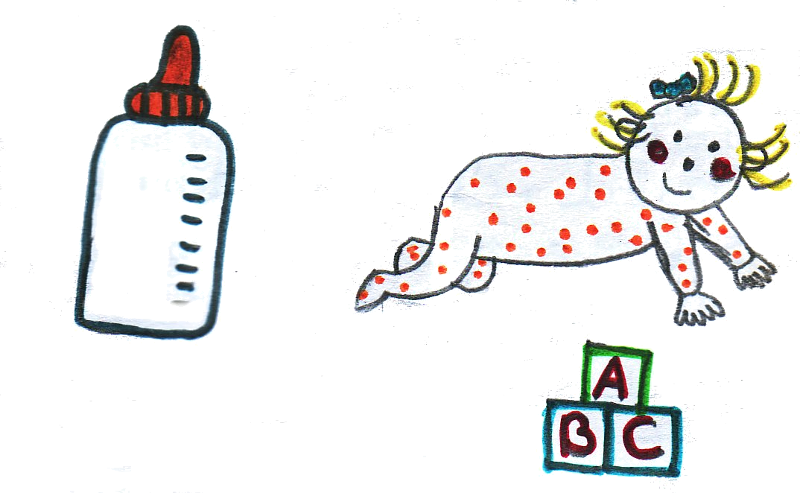

9
Classic books that remain firm favourites
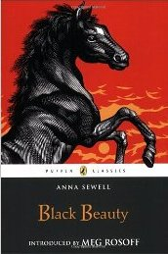

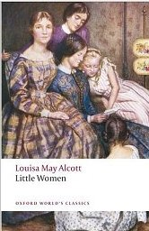
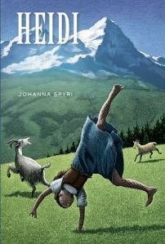

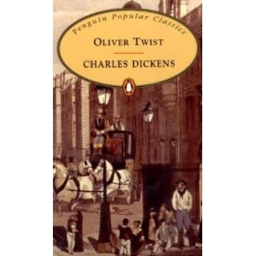

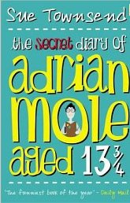
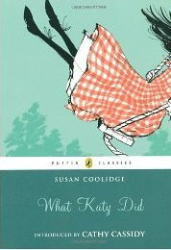

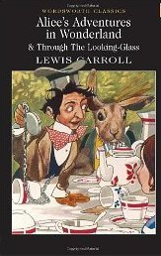

2
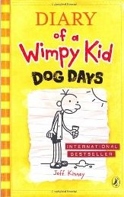
The Diary of a Wimpy Kid series by Jeff Kinney remains a firm favourite.

I enjoyed reading Diary of a Wimpy Kid 4: Dog Days. I went to see the film at the cinema and then decided to read the book. I would definitely recommend this book to others.
Zachary Hannay
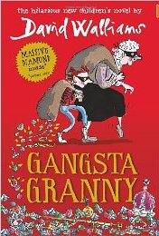
In Gangsta Granny by David Walliams Ben thinks his granny is extra DULL and extremely BORING! She makes cabbage soup and smells of cabbage, so does her house!
Ben suddenly finds jewels in a biscuit tin and finds out that Granny is a jewel thief!
Erin McElhone

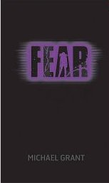
Fear, from the Gone series by Michael Grant.
I liked this book because it is thrilling and has lots of action in it. My favourite part of the book was when Sam and Dekka were carrying missiles in the air (Dekka can make things float) and they fell out of the sky.
I would recommend it because it’s thrilling, mysterious, has lots of action and has a great plot.
Duncan Walker
3
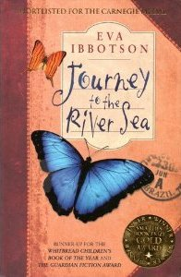
Journey to the River Sea by Eva Ibbotson is about Maia whose parents were killed abroad. Maia’s guardian and solicitor, Mr Murray, finds relatives who will take her in and to Maia’s delight they live in Brazil.
Maia and her governess, Miss Minton, travel to Brazil to start their new lives. They are disappointed, though, to find out that Maia’s relatives, the Carters, do not want Maia but the allowance that comes with her.
The end of the book is very interesting and I would thoroughly recommend it.
Kayleigh Proudfoot

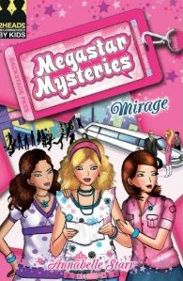
My favourite read was Mirage by Annabelle Starr. This book was all about three school girls helping their idol, pop star Mirage Mullins.
In the book Mirage’s brother, Joe, has been accused of stealing money from the club that he works at. Mirage’s nasty manager owns the club and blackmails Mirage into working for her. At a CD signing Mirage hands Rosie her number to call her and help. However, Simone, the manager, checks all the texts and calls so one night she sneaks into the house where the three girls are staying looking for CCTV footage that is missing …
Read the book to find out what happens next.
Alice Carruthers
8
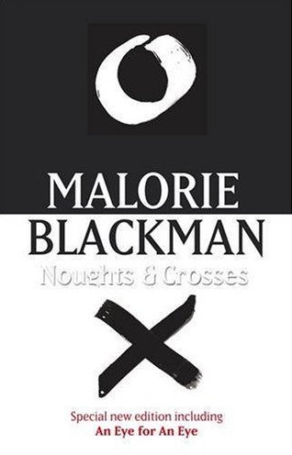
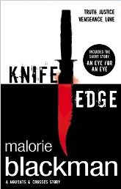
In Knife Edge by Malorie Blackman Sephy has just lost the father of her child Callie-Rose. Sephy is a Cross and her love for Callum, a nought, was not supposed to be. They didn’t care! They went around loving each other as if they weren’t going to get caught, but then Sephy is pregnant…
I fell in love with the Noughts and Crosses books as soon as I had read the first one.
Erin McElhone

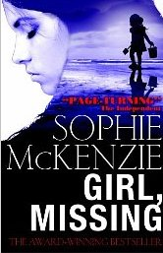
I would rate Girl Missing by Sophie McKenzie a definite 10/10. I recommended it to a friend who enjoyed it very much too!
Lauren is 14 and adopted. She wants to find out about her biological parents but her adoptive parents will not tell her until she is 16. Unable to wait, Lauren’s curiosity gets the better of her and she types in the search engine ‘Missing Children’ to find a young girl similar to her. When Lauren goes to find her real parents she discovers that she was stolen from her family and sold to her adoptive parents. Finding her parents means a lot to her – but she has to make a decision.
Alex McGregor
4
7
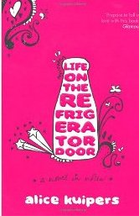
Life on the Refrigerator Door by Alice Kuipers is about Claire and her mum who hardly ever get to see each other but they always leave notes for each other on the refrigerator door. Then one day Claire comes home to find a note from her mum about her breast cancer. As things get worse and worse, more and more notes flood on to the fridge from Claire. Will it come to the worst though? (I’m not telling!)
I really enjoyed this book as it was written differently from other books by being written in their notes. I’d give it 8/10.
Alyx McGregor
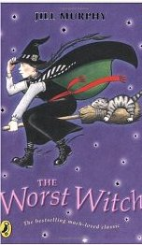
In The Worst Witch by Jill Murphy Miss Hardbroom is the strictest teacher at the school. She teaches about potions. When the pupils misbehave she sends them to Miss Cackle’s office. One warning from Miss Cackle and the next time they’ll be expelled.
I found the story very entertaining.
Megan Anderson
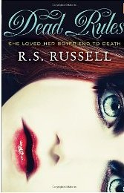
I chose Dead Rules by R.S. Russell because in my three-day visit I got to learn more about the author and he wrote about something he believes in. The book is about a normal girl called Jana Webster but what happens to Jana is not normal at all! You need to find out more for yourself.
Bethany Dunion
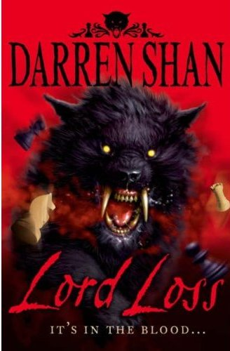
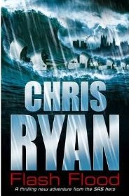
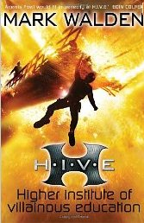
Our favourite summer reads!

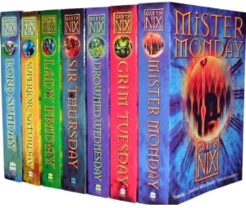
Action and adventure

Heroes and villains galore!

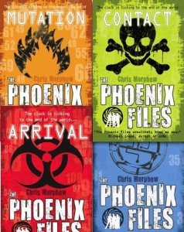
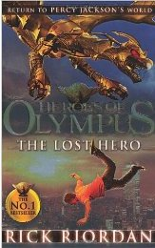

Discover a super series in the school library today!

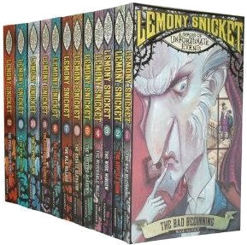
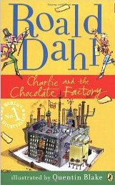
Sweet and bittersweet books – to make you laugh and cry

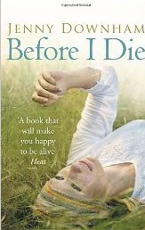

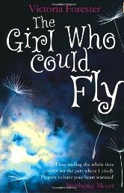
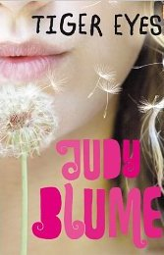

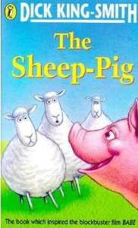

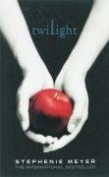
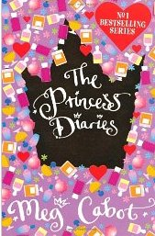

Books to suit all tastes

